**Mylene Homecraft**

**https://deniswad.github.io/Client-Web-Dev-Project/**

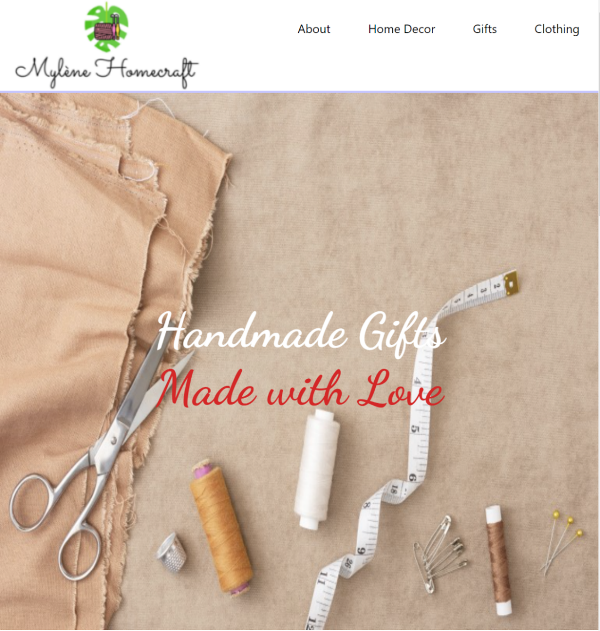

Denis Murray

**Submitted to:** Lisa Murphy

Tuesday 13th of December 2022

Table of Contents

1. Executive Summary 3

2. Project Work 3

3. Design Process 4

4. Testing & Responsiveness 6

5. Conclusion 10

6. References 11

# Executive Summary

My website is based on a real-world, passion project for a family friend named Mylene. Mylene has over the last few years taken up a hobby of crocheting, sewing and generally any handiwork you can think of. Recently, after being given the opportunity to sell her wares at a local market, she realised the joy of selling her goods to interested parties and decided to pursue it as a side business.

I decided to approach Mylene with the offer to create a website for her to showcase her talent, projects and possibly sell some of her goods. We then discussed what would be showcased on the website, a basic structure for the site, and I instructed Mylene to provide me with some examples of her work and some descriptions about herself and her business. After some planning, it was decided that the business is too early in development to allow for any selling through the website but instead, the website would act as a portfolio of her work and talent.

Due to the handmade aspect of the goods, and the fact that it is one person creating all the goods, the market size of the business is extremely limited. Essentially, the business would only be capable of catering to family and friends, and family and friends of those. Custom goods can be ordered but will take a substantial amount of time to complete.

You can find a link to the website here:

<https://deniswad.github.io/Client-Web-Dev-Project>

# Project Work

I completed this project alone. Throughout the development process I maintained constant communication with the client, involving her in many of the design decisions that ultimately helped shape the website. This led to quite a few changes and alterations to my original plans for the project.

Much of this is described below in the Design Process.

# Design Process

Due to project requirement, I decided on Bootstrap as the framework I would use throughout the project. However, I did not want to use Bootstrap extensively throughout as I was worried that the look and feel of the site would become too similar to that of any other Bootstrap based website. As a result, I decided to use the Bootstrap Grid System for the structure of the website. This was extremely helpful for the Products pages (Gifts, Clothing, Home Décor) in particular to ensure uniformity between products. A button to link to the About page, along with a Carousel to link to the product pages for mobile devices was the extent of my Bootstrap usage outside of the grid system.

I followed Mobile First Responsive Design philosophy from the beginning. My media queries are placed at the bottom of the CSS file and the default CSS settings are aimed to serve mobile devices. Responsive units (view height, width, and percentage) are used where possible.

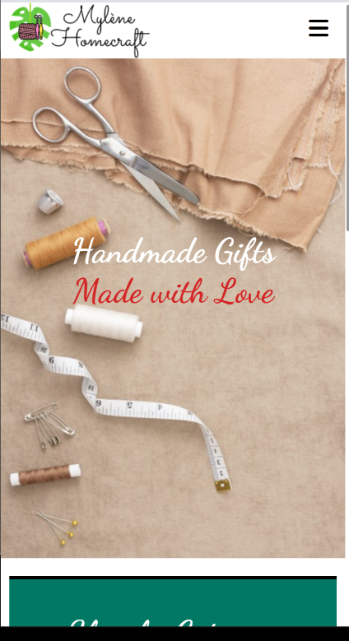

Initially, I had a very minimalistic vision for the website in mind. I dislike websites with too much visual clutter and unnecessary clicking and scrolling to get to the main content. I prioritised readability especially for the About page and the product descriptions as they were the most important aspects for any reader. To improve readability, and to further distance from Bootstrap, I researched some fonts to use. Using Google Fonts, I searched for a font that was easy to read but retained a classy feel. I decided on a font called “Work Sans” and used this for the vast majority of the non-heading text for the site:

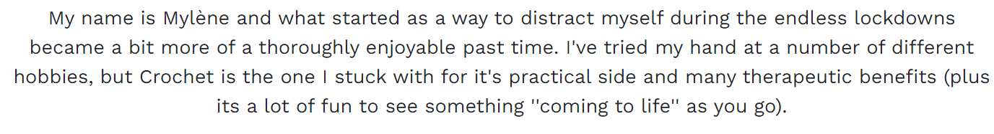As the business creates handmade goods, I wanted to add some artistic flair to the headings. “Dancing Script” was perfect for this and was used for the majority of headings throughout:



I originally intended to retain a basic white background, black font to simulate reading from paper. However, after discussions with the client and through my own usage, I decided that some colour was needed to ensure the site was not too boring to look at. I researched some similar business websites for inspiration.

* <https://www.irishcraftsonline.com/>,
* <https://www.irishhandmadegifts.com/>,
* <https://www.katelynmckenna.com/>
* <https://www.hallmark.com/>

I decided to use a colour combiner and colour scheme guide website - <https://paletton.com/> and choose a Triad colour scheme. My base colour of #007864 is used extensively throughout the site as a background colour (see the Shop by Category screenshot above). #B60015 was used for the home page tagline only.

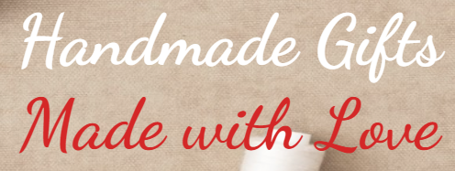

White was used as the primary font on sections where the base green colour above was used as a background. This was due to the fact that white text on a green background is more legible than darker text on the same background.

*Initial Concept: Final Version:*

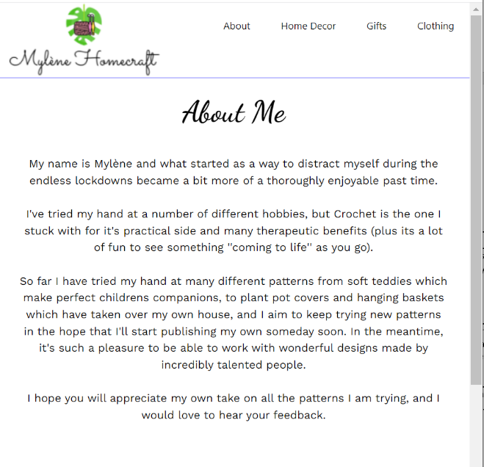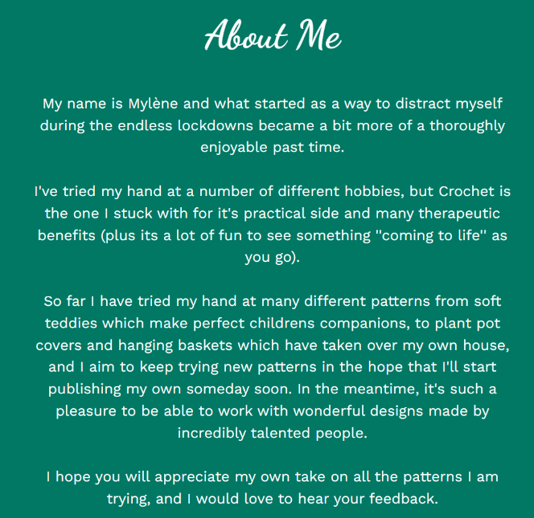

To ensure the client felt a connection with the site, I decided to make a custom logo using the logo designer: <https://www.freelogodesign.org/>. I asked the client what sort of a logo she would like, what does she feel represents her business to her. I was told that Crochet Needles and a Monstera leaf would be ideal. After some discussion about what leaf that looked like with the client we decided on the final version. I ended up using 2 separate final versions, 1 for mobile and 1 for other devices:

*Concept: Final bigger devices: Final mobile devices:*

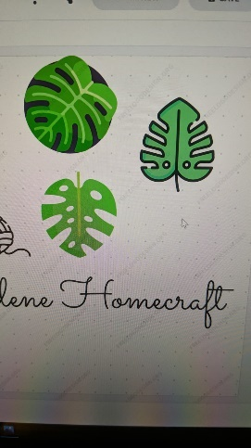

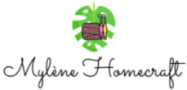

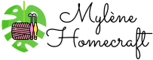

# 

For the dropdown menu, I needed a hamburger menu icon. I used Font Awesome for this: <https://fontawesome.com/>

# Testing & Responsiveness

I followed Mobile First Responsive Design principles. By default, CSS was structured towards mobile devices. For bigger devices, I utilised Media Queries. I based my breakpoints on the default Bootstrap breakpoints:

@media (min-width: 768px)

@media (min-width: 1200px)

@media (min-width: 1400px)

I used the media queries to change elements of the website as device sizes increased. For example, the home page has a background image covering the full viewport width on lower sized devices. However, on wider screen devices, this only covers 85vw and 75vh as screen sizes increase. This is to reduce stretching and to reduce screen space used on those very large devices:

Smaller Devices 100vw: Wide screen devices 75vw:

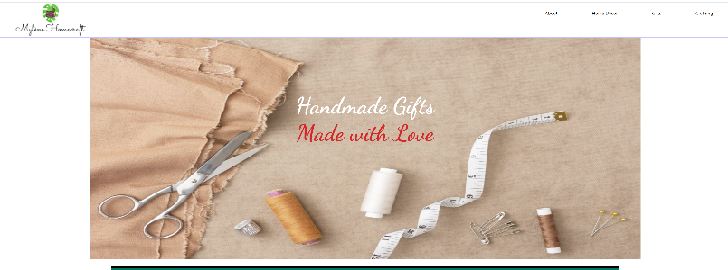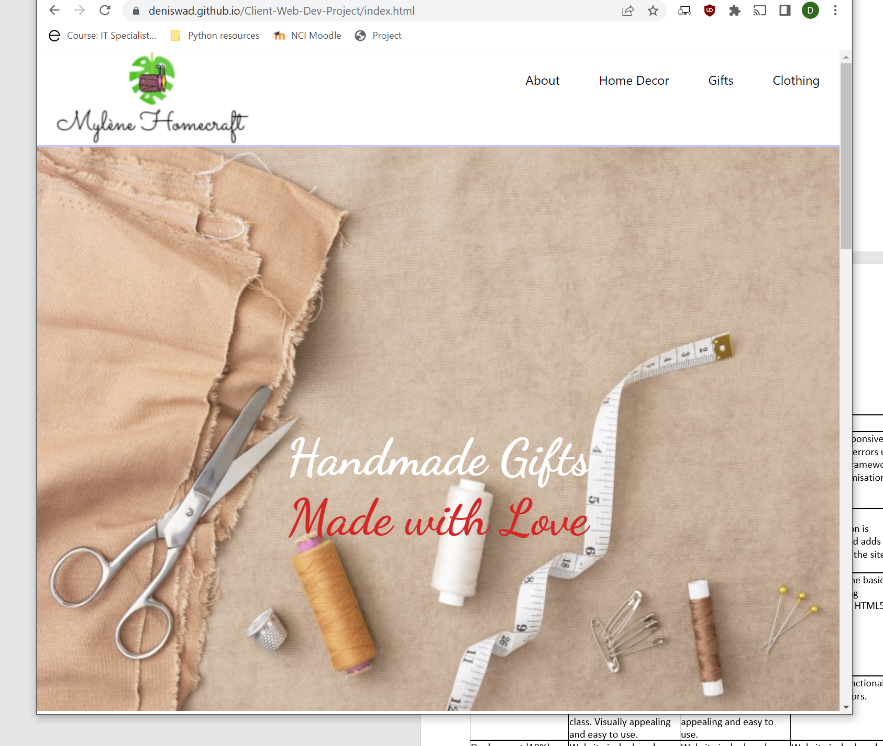

Following good optimisation practises, I reduced the size of the majority of images to the size they would be displayed on the screen. For example, the custom logo that was used was originally a huge file in dimensions. I cut this image down using Paint 3D image editor to the size it would be represented on the site:

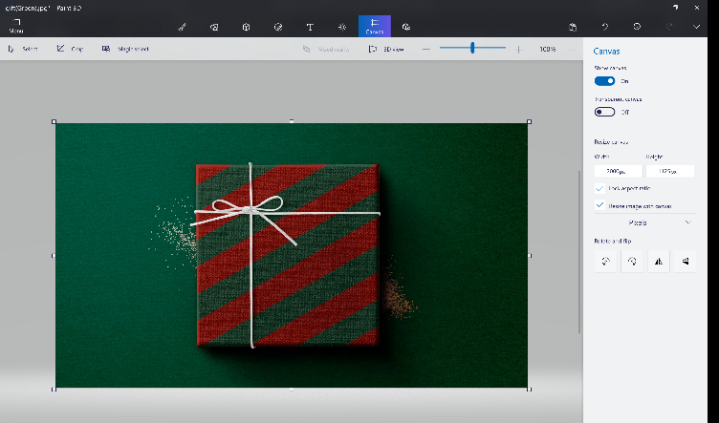

Google Page Speed Performance:

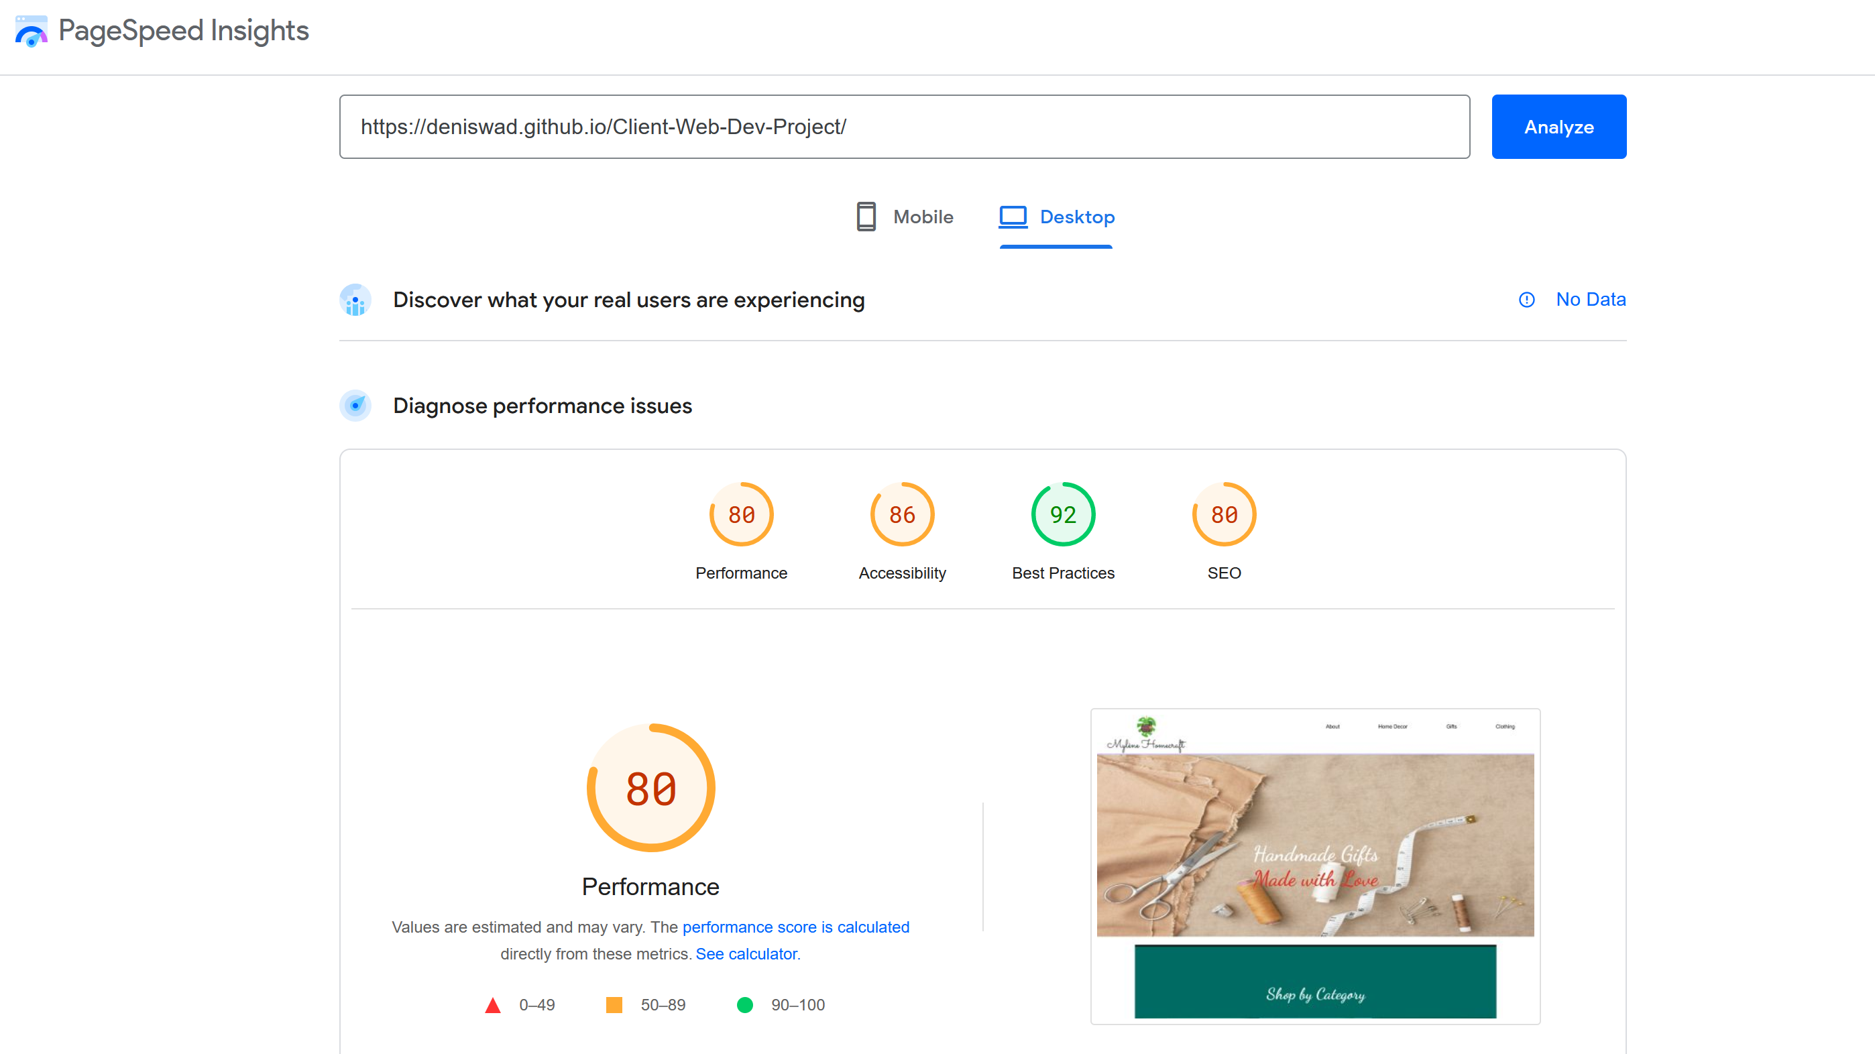

JavaScript was used to control the dropdown menu in the navbar for all mobile sized devices. Upon clicking the “hamburger menu” logo, an “onclick” event handler calls the openHamburgerNav() function in script.js. This function checks the state of the navbar and if it is hidden, causes it to appear. If it is visible, it causes the menu to disappear. Form Validation of the contact me form is written in the script.js page and syntax is correct, however it is not implemented correctly as the form does not action to an outside page yet. I could attach this to a fake submit button and use an onclick event handler but I do not believe that would be accurate to how it should be handled.

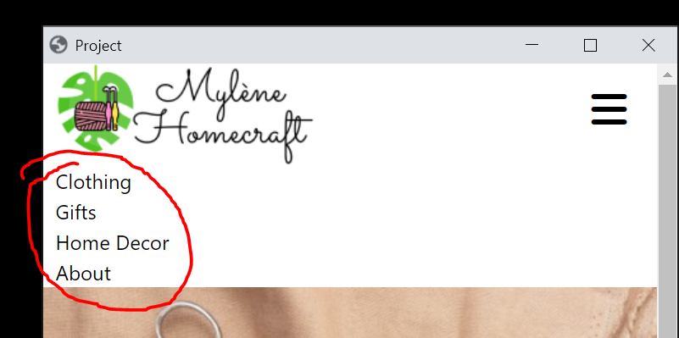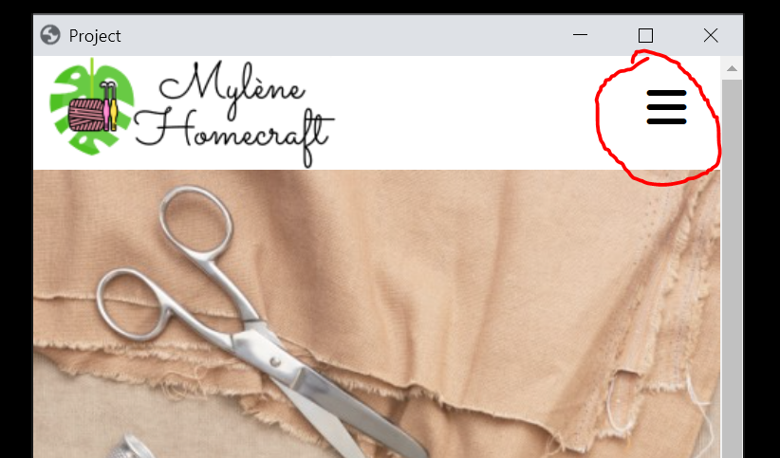

**Wireframes:**

I created some very rough wireframes that I intended to follow closely. I am very happy with how I was able to convert the concept structure of the site to the final version:

Home Page:

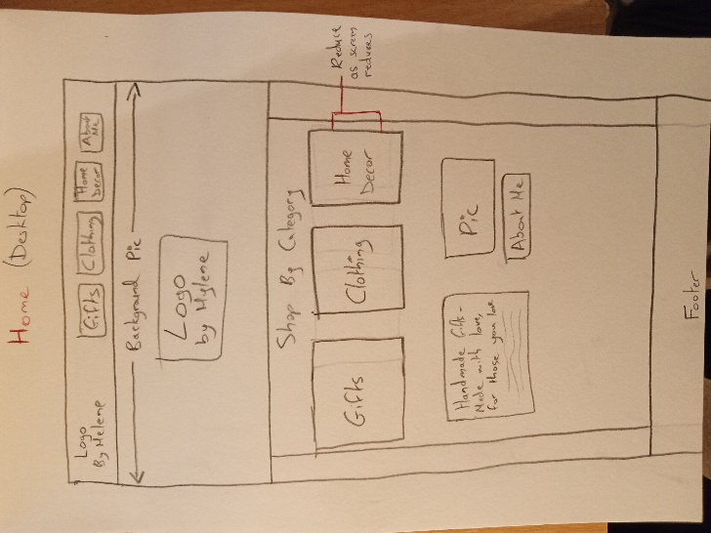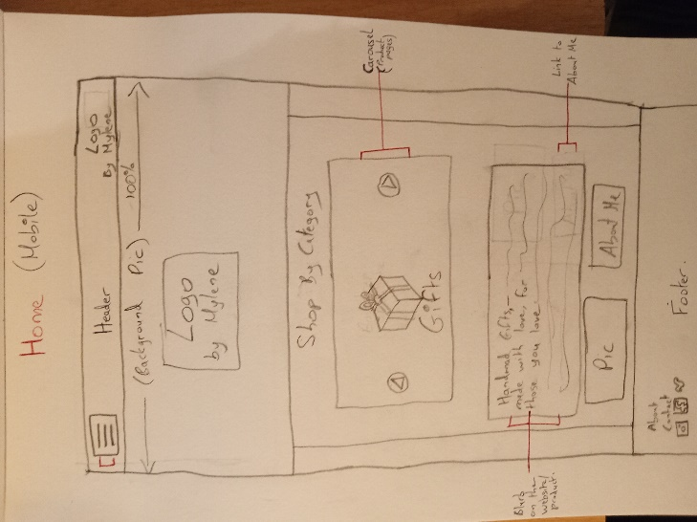

Product Page:

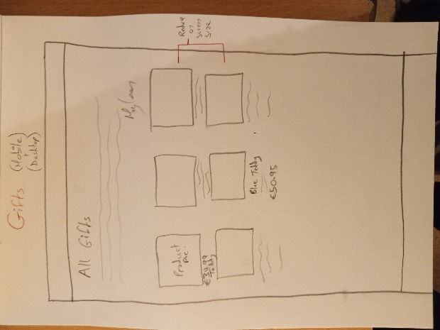

About Page:

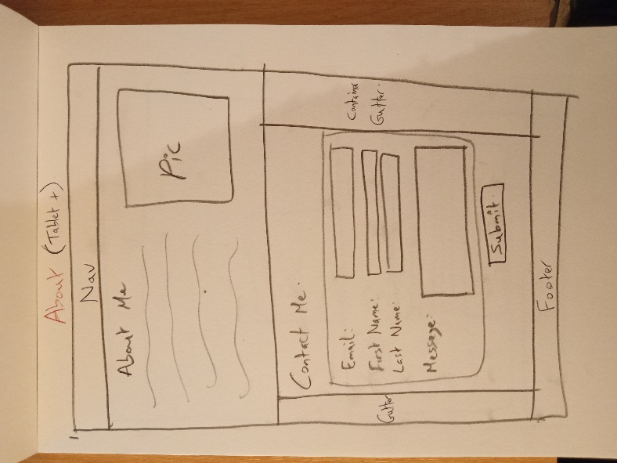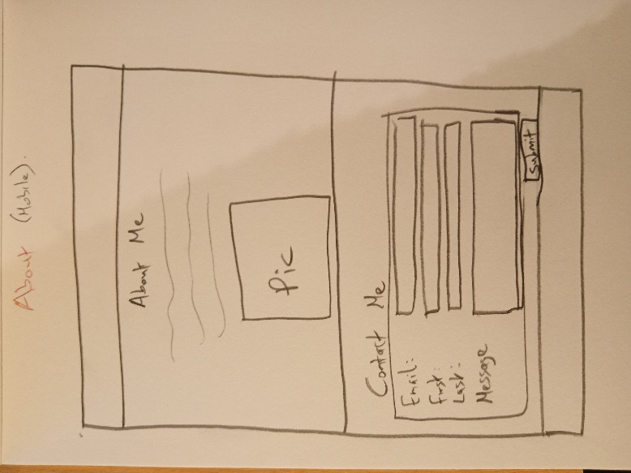

# Conclusion

Overview of how the project went, did you work together well as a team (if you did work in a team). What was difficult to do, how you feel the website looks and if you had time, would you make any changes.

Overall, I am quite happy with how the project went. The end result is very close to what I had planned out and this is the first time I have successfully followed Mobile First responsive design. The client is also very happy with the result and has plans to continue hosting the website. Further work is required to get the site up to full production standards but for the timeframe, I am satisfied. If the project is to be continued, I will look to add selling functionality to the site later down the line.

Ensuring uniformity between 4 separate device sizes ended up being the most time-consuming and difficult process. Testing of all four when a change was made late to the navbar for example was tedious.

I am very satisfied with the functionality of the website although I am not entirely happy with the end result. If I had time, I would invest more time ensuring spacing and padding of elements were more accurate. I would like to spend more time on the navbar in particular as, even though I prefer a minimalist approach, the navbar could have more advanced styling. I would also like to implement more SEO and Speed optimisation because even though there is some, better optimisation could be achieved.

# References

Google. (2022, December Thrusday). *Google Pages*. Retrieved from Google: www.google.ie

Websites used for inspiration:

* <https://www.irishcraftsonline.com/>,
* <https://www.irishhandmadegifts.com/>,
* <https://www.katelynmckenna.com/>
* <https://www.hallmark.com/>

Colour scheme website:

<https://paletton.com/>

Logo Designer:

<https://www.freelogodesign.org/>

Logo Inserts:

<https://fontawesome.com/>

Google Fonts:

<https://fonts.google.com/>

Google Fonts CSS links:

<link rel="preconnect" href="https://fonts.googleapis.com"><link rel="preconnect" href="https://fonts.gstatic.com" crossorigin><link href="https://fonts.googleapis.com/css2?family=Dancing+Script:wght@700&display=swap" rel="stylesheet">

Basic form validation:

https://www.w3schools.com/js/js_validation.asp

Form Structure:

https://www.w3schools.com/howto/howto_css_responsive_form.asp